School Charter

Strategic and Annual Plan for

Westport North School

2017 -2020
Principals’ endorsement: | 1st March 2017/ February 2018/February 2019/ February 2020
Board of Trustees’ endorsement: | 7TH March 2017/ February 2018/25th March 2019/ 9th March 2020
Submission date to Ministry of Education: | 9th March 2017/ 1st March 2018/1st March 2019/10th March 2020

Westport North School 2017 - 2020
Introductory Section - Strategic Intentions
Mission Statement | To provide a quality learning environment that nurtures and maximises students’ emotional, social, intellectual and physical development based on our shared values.
Vision | When our students leave at the end of year 8 we want them to be;  Confident and Happy,  Positive Contributors,  Motivated and Self- Regulated,  and have a Strong Academic Foundation
Values | RESPECT: for self/others/our environment/learning/our identity  Manaakitanga Kaitiakitanga Tohungatanga Rangitiratanga  RESPONSIBILITY: through leadership & citizenship  Tikanga Rangatiratanga  RELATIONSHIPS: creating connections between people  Whangaungatanga
Principles | 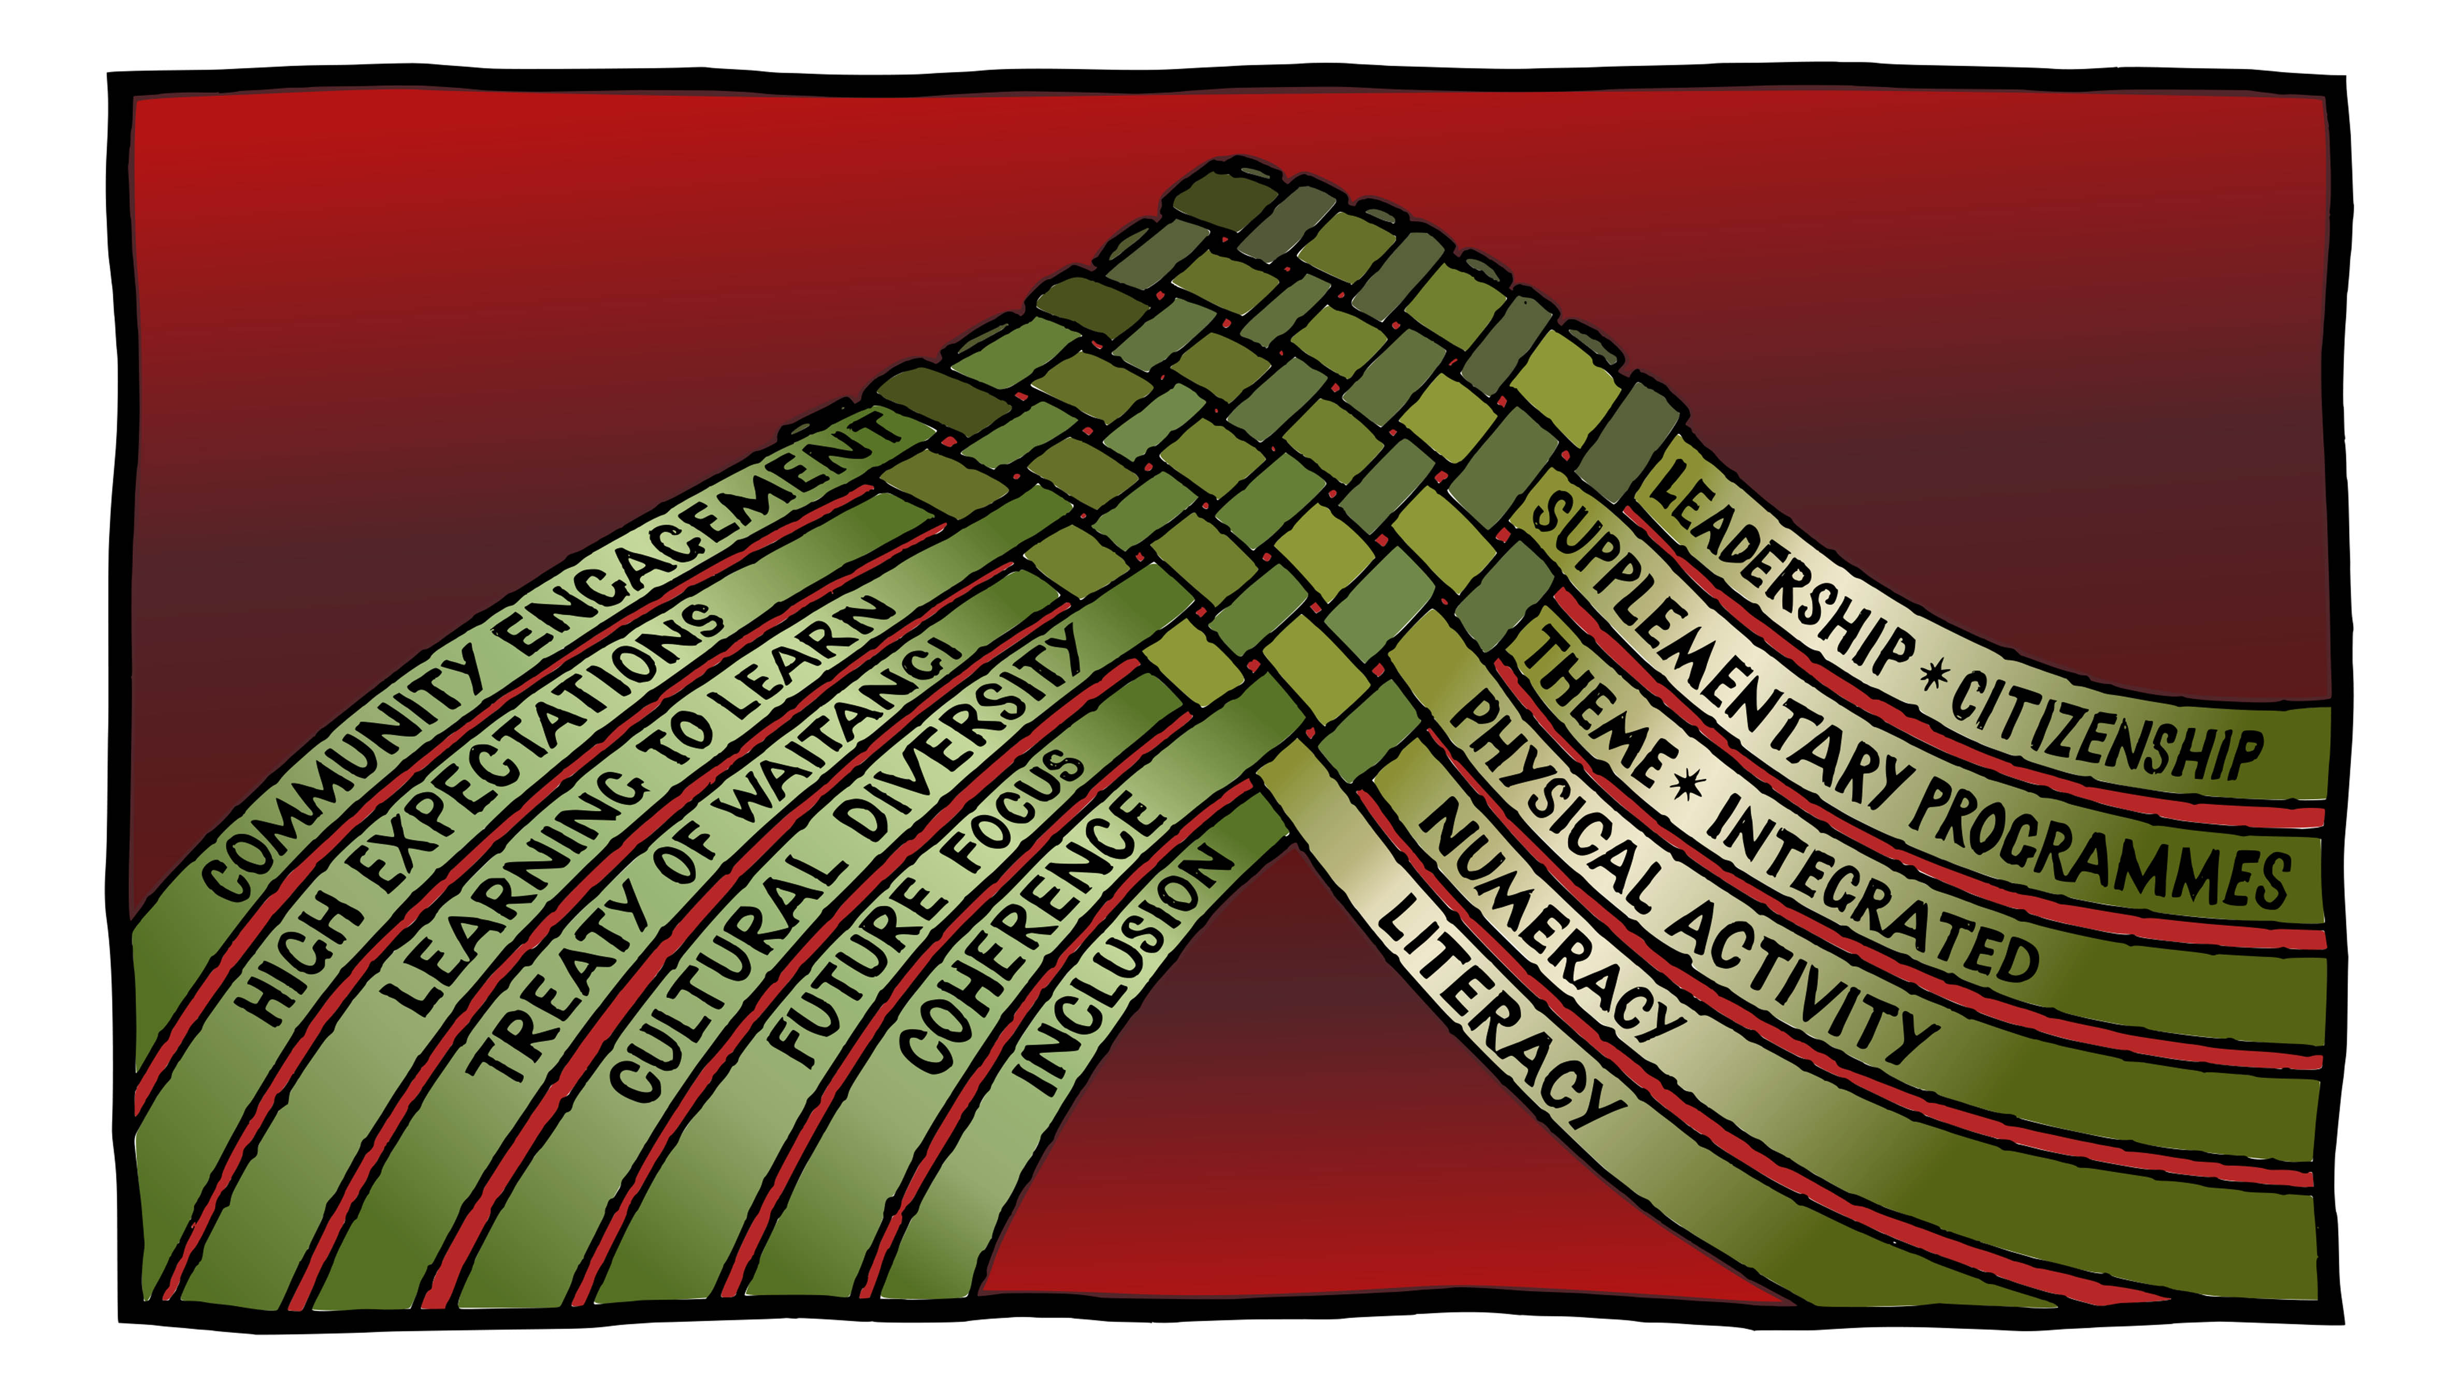  The Woven Threads demonstrate how our school based curriculum links to the Principles contained in the New Zealand Curriculum document.
Māori Dimensions and Cultural Diversity | Recognising Cultural Diversity  Westport North School has developed policies and practices that reflect New Zealand’s cultural diversity and the unique position of Maori.  In recognising the unique position of Maori, Westport North school has ensured that it can provide instruction in Tikanga Maori and Te Reo Maori for full time students whose parents request it through the development of its bi-lingual classrooms – Eke Panuku.  Tikanga and Te Reo Maori are also recognised in every classroom and opportunities to provide Maori perspectives are taken in theme work wherever possible. This work is also supported by the bilingual teacher.  To enhance this the school will continue to:  - Consult with the Maori community  - Engage RTM  - Provide Staff PD/ advisory support utilized  - Develop the existing programmes as appropriate  - Participate in the Kapahaka Festival  - Combine with local schools for parts of the Programme  Provide adequate support and resources to enhance inclusion to Te Reo and Tikanga through-  - Extra resources  - Specialist support-80 hours PLD in 2018  - Computer information  - Support implementation of Te Aho Arataki Marau mo te Ako i Te Reo Maori into school programmes.  Westport North School recognizes and celebrates all students’ and whanau cultural identity and ensures that identity, culture and voice of every student are reflected in their programmes of learning.
Special Character Māori Medium status | Westport North School has a bilingual unit, Eke Panuku, in 2017 this was on hold with the students being catered for in the mainstream while a permanent staff member completed the Hoaka Ponumu immersion teaching Diploma. This resumed as a Level 3 class in 2018.  Westport North School has a Sports Academy class which caters for students from Yrs 6-8. Students are taught skills for all sports and the emphasis is on holistic education, fitness in both body and mind.  Westport North has been part of the William Pike Challenge Award since 2010, this is a very high status programme that attracts applications from many more senior students that it can cater for (12) Students whom have completed this programme have gone on to be Head Boy and Head Girl at Buller High (2016, 2017,2018)

BULLER CoL ACHIEVEMENT CHALLENGES

Achievement challenge 1: Literacy (ECE)
Measuring Literacy through the six-week assessment and matching it back to the three ECE’s Why? To identify student progress and also the level of expertise/programmes at the various ECE’s. We are still in conversation with the ECE’s and primary schools regarding a sensible measure and how we measure ‘value added’ for these students.

Achievement challenge 2: Literacy - Reading (Years 8)
To improved reading levels across all primary schools, to provide the opportunity for greater success across all curriculum levels and areas at high school, Measured through the curriculum level

Achievement challenge 3: Literacy (Years 11 – NCEA Level 1)
To reintroduce reading and Literacy as important functions across the high school curriculum. To provide learning activities to support the growth in active reading and subject specific Literacy strategies

Achievement challenge 4: Raising Attendance
We know that raising attendance will raise achievement (ministry data for high school indicates a clear link between attendance and the accumulation of NCEA credits – Megan Parry).

Academic Targets
Students’ Learning | Westport North School Targets  Writing; Accelerate students in years 3 & 8 so that they will achieve or above their respective curriculum level-22 students (Year 3-11, Year 8-11) To accelerate the learning of Maori students in the mainstream so that they achieve at or above the whole schools (Maori 69%, Whole School 74%) Maths and Stats; To accelerate the learning of those students in Years 3, 7 and 8 who are at risk of not meeting the expected curriculum level by the end of the school year. -31 students (year 3-14, Year 7-8, Year 8-9) Reading; students To accelerate the learning of Year 3 girls and Year 5/6 boys so that will achieve at or above their respective curriculum level -18 (Year 3-10, Year 5-3, Year 6-5)  These targeted students will be closely monitored throughout the year.  We aim to increase this to 84%
Student Engagement | Student engagement is high at Westport North and support is attached to any student struggling to engage in any aspect of the curriculum. We are a PB4L school and take pride in knowing the language, culture and back stories of all our students. Student voice is sort in decision making and curriculum development. Welbeing at School surveys are collected from students and teachers annually and results discussed with all concerned. Changes of programmes can arise from these discussions. Wellbeing is practised in all classrooms.
School Organisation and Structures | The school has 10 classrooms operating in 2019.Eke Panuku (Bi-cultural level 3 Yrs 3-8) 1 new entrant room, 1 Yr 1 class (BOT funded) 2 Yr 2/3 classes 1 Yr 4 class, 2 Yr 5/6 classes 1 yr 7-8 class and a Sports Academy with students from Yr 7-8.  We are organised into two teams; Yrs 1-4 and Yrs 5-8.
Review of Charter and Consultation | Charter reviewed by BOT March 25th 2019. Full consultation with all stake holders was carried out in 2017 and will be again in 2019

What ERO said about Westport North School

2 School conditions for equity and excellence – processes and practices
2.1 What school processes and practices are effective in enabling achievement of equity and excellence, and acceleration of learning?
The school has a number of highly effective processes and practices that are enabling equity and excellence.
Students, parents and whānau are highly engaged in learning within the school and in the wider community. Leaders and teachers use a range of highly effective strategies to know the students as individuals, as learners, and family and community members. They are very active and committed to involving all parents or whānau in decisions for their child’s learning and wellbeing. They keep parents and whānau well informed and engaged with school and home learning. Students are motivated learners who know their parents and whānau are proud of their successes and support them in their learning challenges.
The school curriculum is meaningful and responsive to students’, parents, whānau and the community’s expectations, interests and values. Leaders and teachers regularly seek the opinions of students, parents and whānau to ensure class programmes are interesting and relevant. Teachers use a wide range of effective teaching strategies to engage and progress children’s learning. The school and class environments are caring, collaborative and inclusive. Students are confident, highly involved learners who respect and include the opinions of others.
Māori students are increasingly experiencing success as Māori and are proud of their bicultural heritage. Māori language and culture are valued by leaders, teachers and students. They have a strong commitment to continue to increase te reo and tikanga Māori in all classes and throughout the school. Authentic expression of Māori values are highly evident. Māori students and all students are well supported in holistic ways through wide spread tuakana teina relationships.
School leaders effectively build professional capability and capacity. They have built a strong, collaborative team where individual staff strengths and interests are effectively used to benefit the learning and wellbeing of all students and their families. Teaching across the school is closely aligned to the school vision, values and goals. Professional development is well planned and targeted to achieve the school strategic goals. Strong relational trust has built robust educationally focused relationships to support equity and excellence for all students.

Strategic Section

Strategic Goals  To provide a quality learning environment that nurtures and maximises students’ emotional, social, intellectual and physical development based on our shared values |  | Core Strategies for Achieving Goals  2017 - 2020
Students’ Learning  Goal 1A | High expectations of student achievement  Objective 1  Accelerate achievement of priority learners | - Group Learning Plans established and monitored for target students and all students achieving below their expected curriculum level in Maths and Stats and Literacy  - Three years of Accelerated Literacy Learning (ALL) practises now embedded into  - ‘In addition” teaching strategies timetabled in all rooms-Teir two teaching  - Two years ALiM (Accelerated Learning in Mathematics)  - Students at risk not responding to in school initiatives will be referred to the appropriate service, i.e., SWIS, RTLB, RT Lit, ICAMh, GSE, SLT.  - Teaching as Inquiry model is used to support target student achievement  - Appraisal system includes teaching as Inquiry focus  - Principal and curriculum leader walk-throughs
Goal 1 B | All learners make progress to achieve their goals.  Objective 2  To ensure student achievement data is used for effective decision making. | - PB4L data analysed and discussed by all staff and student leadership group  - Welbeing in Schools Survey completed bi-annually with students and staff. Results discussed with BOT, students, staff and community.  - Data is entered into SMS by appropriate dates.  - Implement Assessment for Learning Practices. Student co-construction and use of success criteria. The use of effective feedback strategies based on next step learning.  - Achievement statement is being used in teacher planning.  - Group Learning Plans established for all students achieving below their expected curriculum level.  - Train any new staff in the effective use of the SMS- Musac Edge
Health Curriculum Consultation |  | Panui sent home week 2 of Term 1 – up-dates will be sent home as programme progresses.
Goal 2  Goal 2 (Con) | Engaging families/whānau and the wider community to support positive student learning outcomes.  Engaging families/whānau and the wider community to support positive student learning outcomes. | - Meetings with senior management team to plan, report on community engagement activities and home and school links.  - Community voice on the SWPB4L Team.  - Produce and publish tri-weekly school newsletters. Publish hard copy, school website, Facebook ,.Skool -Loop Enhance school website.  - General information Regular updates of classroom presence. (ICT Coordinator)  - Community consultation enhancements, survey monkey, phone-arounds, school gate interviews. Northern Lights  - Goal setting meetings - Parent information/support for learning programmes.  - Media team –students doing weekly radio segment  - Report Kahu Ako up-dates to whanau  - Embed APPs such as SeeSaw or Doyo as a means of sharing student work.  - Student Learning Conferences Term 2  - Northern Lights  - Strengthen North Star Awards, continue with development of whanau/teacher North Star Awards  - Maintain Summer Reading Packs as requested  - Engage parent/ community assistance for fundraising ventures. Community input into significant school wide events. e.g., Tabloids Day, Sports events, Northern Lights, Twilight Gala, School Production.  - Implementation of EOTC recommendations. Greater use of the local environment and community resources to support learning programmes.  - Maintain effective liaison with preschool providers. Regular 2-way information sharing. Explore transition possibilities. All new entrants are buddied up with senior students.  - The board of trustees works with the school community to develop and regularly refresh the school's vision, values, strategic direction, goals and priorities for equity and excellence.
Goal 3 | Ensuring that Westport North School is a safe, happy, attractive learning environment consistent with the School Vision | - 10 year plan approved by Ministry -5 year money available July 1st 2020  - Property manager appointed by BOT- May 2020 will need to get three quotes  - Environment is attractive and well maintained  - Modernise classrooms as per 10-year plan- July 2020  - Garden area – Annual plan and growing calendar being worked on for 2020-  - Orchard replanted as part of makeover  - SNUP up-grade completed., wireless network maintained to high level of coverage.
Student Engagement & Transition | At Westport North School we offer a curriculum that has meaning for our students, connects with their wider lives, and engages the support of their families, whanau and communities | - Improve attendance. Ministry now collecting attendance data termly.  - Use attendance data to inform decisions.  - Letters sent to any student attendance falling below 80%  - Strengthen links with Early Childhood services  - Continue to grow Kahui Ako and strengthen links with local schools  - The board of trustees proactively develops networks that strengthen school capacity to extend and enrich the curriculum, learning opportunities and pathways for students and contributes to other schools' capacity to do so.  - Continue to engage with new curriculum tools developed by the Ministry of Education
Finance | At Westport North School the BOT are committed to using the funds allocated in any given year for the education of the students enrolled. | - Operate within annual grants.  - Monitor Annual budget  - Identify budget lines at risk of going into deficit  - Apply for community grants as appropriate.  - Positive Annual audit report received  - Sign up for Ministry funds rather than donations √

Other 2020 Key Improvement Strategies to Achieve Strategic Vision
Property (summarised from property plan) | Short Report | Finance | Short Report
Projects identified for 2019 in 10-year property plan are finished.  Grounds are attractive and well maintained | Have met with the Ministry and Logic to complete draft 10 year property plan  Work continues on the special needs modification project- Blinds installed  Meeting notes attached | Annual accounts sent to Ministry in timely manner.  Budget monitored  Staffing monitored and kept to acceptable level  Student activity fees collected- this is not the voluntary donation  Camps are self-funding  William Pike Challenge is self-funding  Satisfactory Audit Report
Personnel | Short Report | Community Engagement | Short Report

Ensure that 100% all Teaching staff meet the Criterion dimensions of the Registered Teachers Criteria.  Teaching Assistants feel valued and supported  Leadership builds the capability of teachers to be leaders who promote and support the improvement of teaching and learning | Living wage from March 2020  Accessing Professional development continues to be an issue, cost of travel, course costs etc. | Consultation carried out in a meaningful way.  Parents, whanau and the community are welcomed and involved in school activities as respected and valued partners in learning  Leaders and teachers actively participate in community activities | Health Consultation completed – one response.  Whanau presence at Tabloid Sports and Top Team.

